Exercise 2 Report

This exercise was interesting as it was more focused on the performance of convolutional neural networks on CPU and GPU. Initially, there were some issues with the tensorflow, as it was difficult to install. Few searches on the web, helped in setting up tensorflow and work on it.

After setting up all the layers, as specified in the exercise, different learning rates were tested and the accuracy of the neural network was monitored, keeping the number of epochs constant. The following graph was obtained

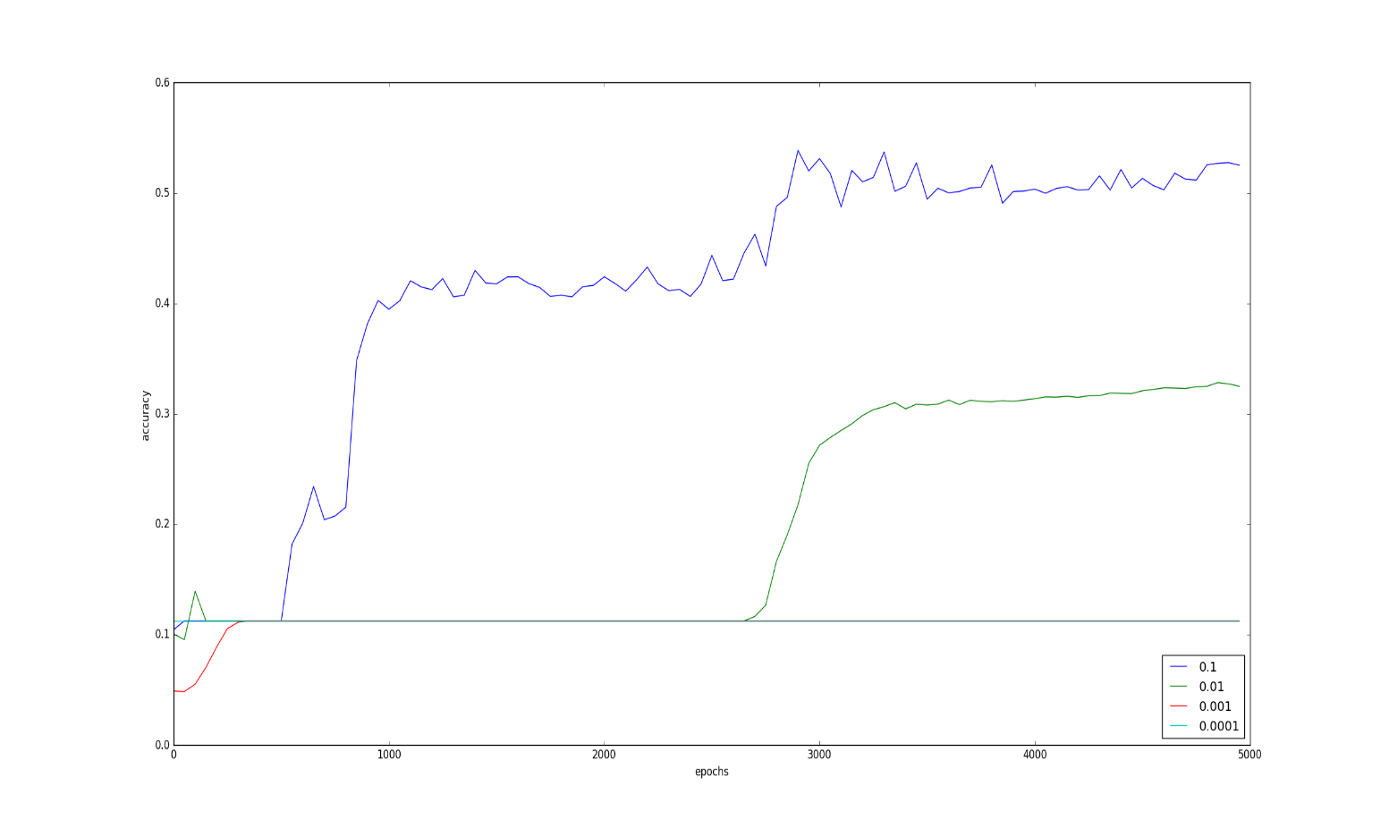

As the learning rate was increased, the accuracy of the neural networks improved drastically. The learning rate of 0.1 yielded the best results in this amount of iterations. The learning rate of 0.01 showed better results, achieving an accuracy up to 30%. For the rest of the learning rates, the iterations were not enough to yield a good output. This shows that a higher learning rate would improve a network’s performance in limited epochs.

The third part of the exercise was based on performance of CNN in CPU and GPU by varying the number of filters in the convolutional layer. Although computations in GPU was much faster than those in CPU, the pool account had only limited amount of internal memory, causing the network to run out of memory when the filter size reached 64. Therefore, the script didn’t run successfully in GPU and graph couldn’t be obtained. The runtime scatter plot for the CPU version is as follows

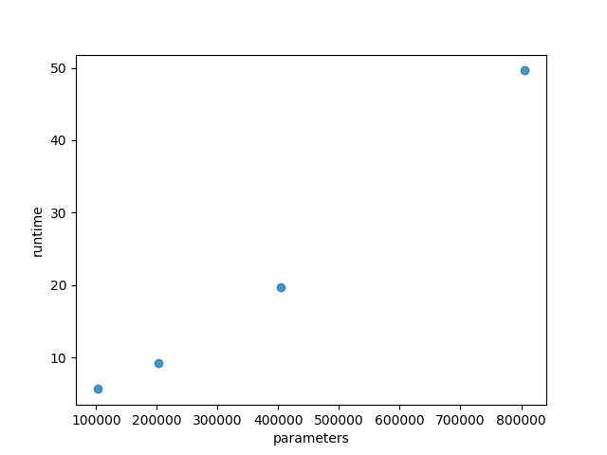

As you can see, as the number of parameters increase, the runtime (minutes) increase drastically.